Express222™
Controlled Substance Ordering System
User Quick Reference Series

Finding a Digital Certificate File on Your Computer
This Quick Reference will help you locate a copy of your DEA-issued
digital certificate on your computer in the event it is no longer
available in your Internet Explorer browser.

In the event you already have a DEA-issued digital certificate, but it was not originally installed in Internet Explorer, you might need to locate the file on your computer in order to be able to use it with Express222™. To locate the file, open Windows Explorer on your computer:
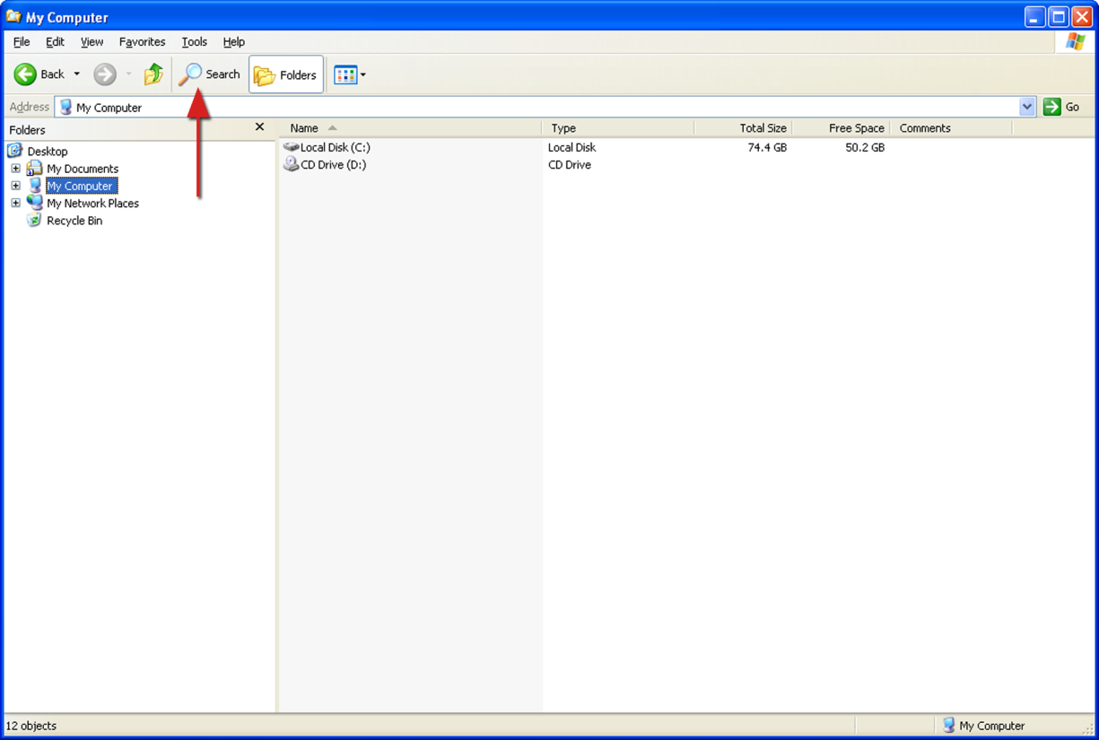
Click on the “Search” button. The Search Helper is displayed: 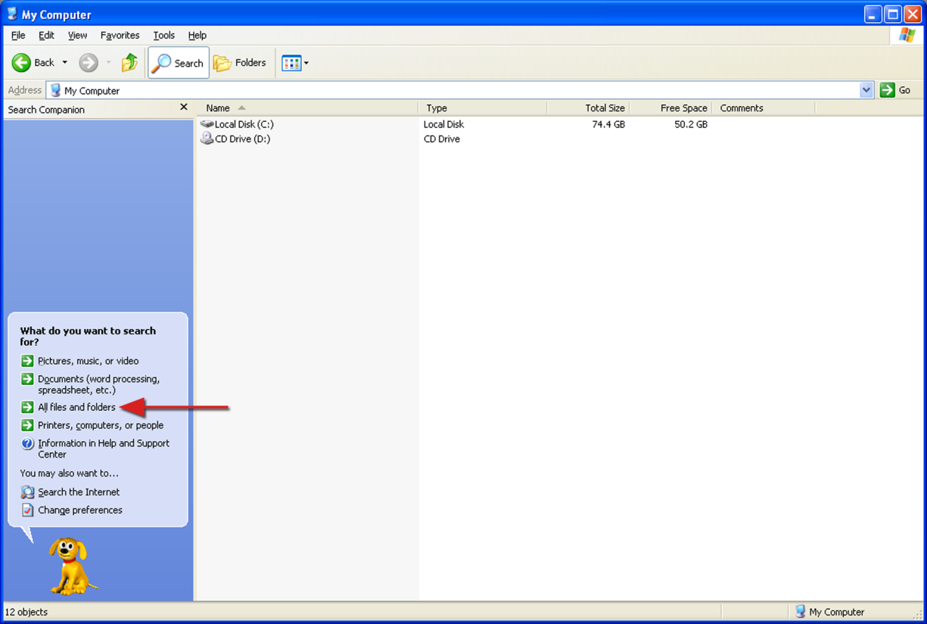
Click on the “All files and folders” option.
The Search Criteria form is displayed:
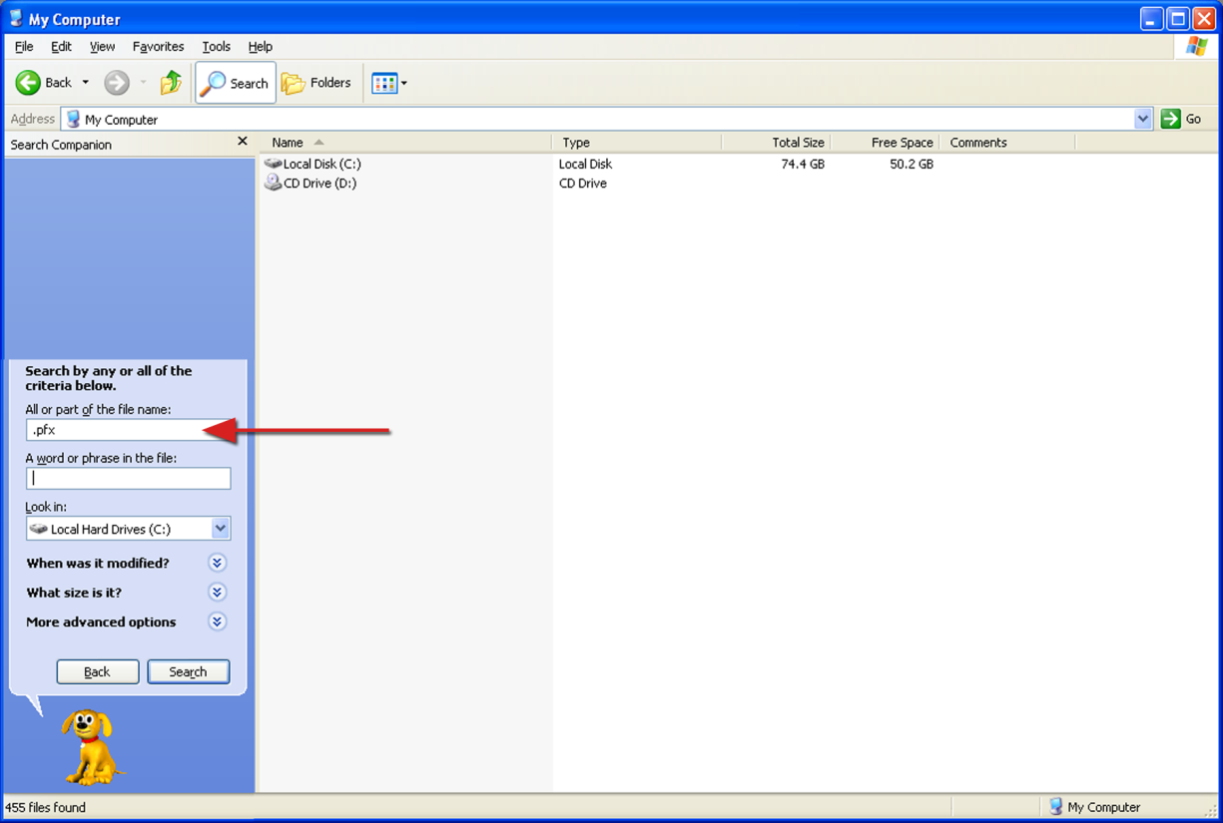
Type “.pfx” in the file name box. If you have an idea where the file might be, you can narrow the search by selecting something other than “My Computer” in the “Look In” dropdown list.
Click on the “Search” button.

A search will be conducted for all certificate files on your computer. When the search is finished, the results are displayed:
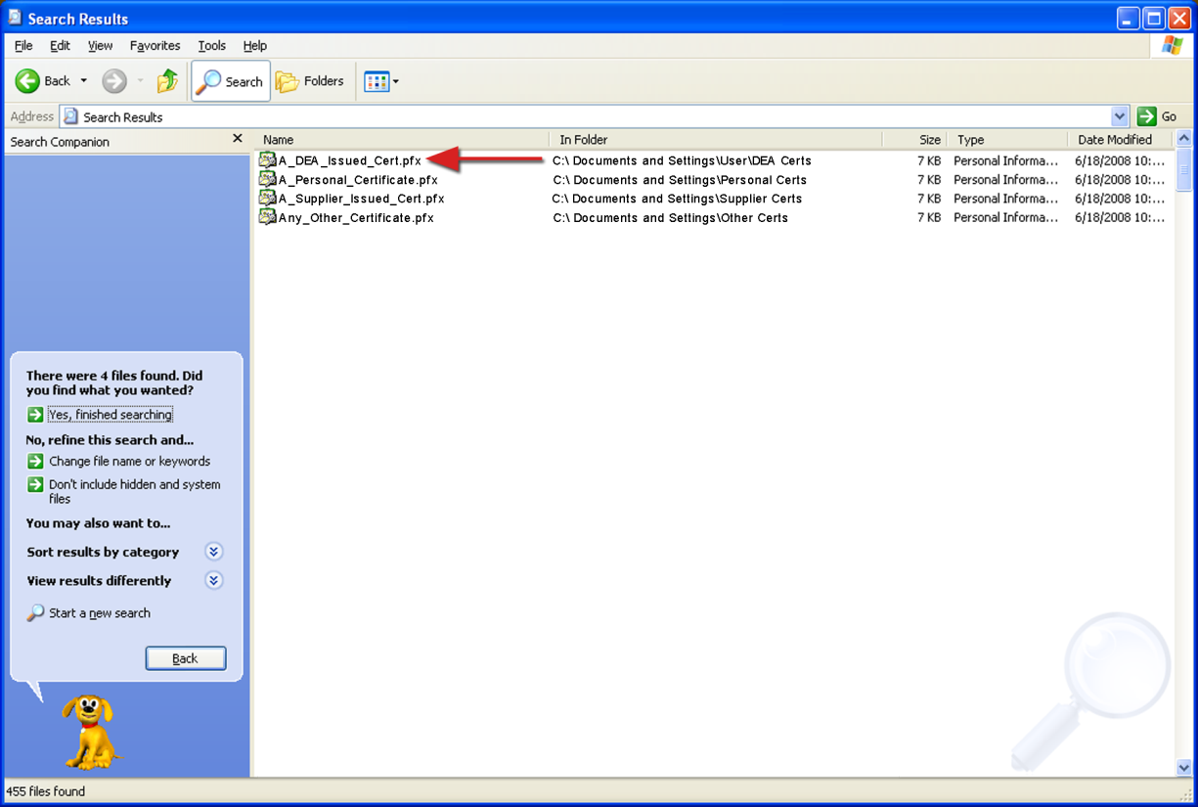
Since you might have several different certificate files on your computer, scan the search results carefully to make sure you locate the certificate that was issued to you by the DEA specifically for signing CSOS orders. This is the only certificate that will work for this purpose.
When you have located the file, you can proceed with the certificate installation instructions in the companion document in the User Quick Reference Series entitled “Installing a Digital Certificate in Internet Explorer”.

